Term: Summer One | Year 1 Home Learning
Our spellings for this half-term:
Week 1  play  made  sea  fever  tray  game  treat  secret  they  sure  pure  said | Week 2  lie  time  both  home  cried  like  over  note  were  one  says  here | Week 3  blue  new  use  saw  true  flew  rule  straw  today  their  people  your
Week 4  bread  bird  sound  joy  thread  girl  out  annoy  any  many  who  whole | Week 5  mind  later  show  music  child  baking  grow  unit  two  eye  thought  through | Week 6  Revisit previous spellings
3
1
2
Reading
Number Facts
Spelling
Homework; as simple as…


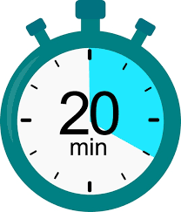

Key Weekly Focus:

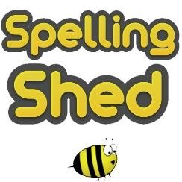
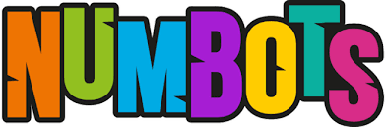
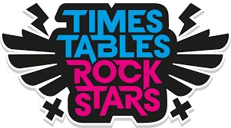

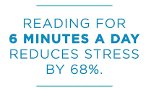
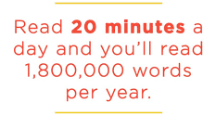
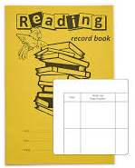
Optional Focus:
If you are seeking additional home learning resources, please visit our class blog, where we share the week's learning activities. We occasionally include supplementary links in the blog for further practice opportunities. Furthermore, utilise the websites we use in school to enhance learning. IXL offers English and math resources that align with our curriculum focus. Spelling Shed enables children to practice spellings pertinent to their year group, in addition to the weekly spellings. TTRS helps children improve their recall of multiplication tables, which are essential for most of the KS2 maths curriculum. Numbots is most effective in KS1 for reinforcing number bonds. Some students in school have access to Nessy, a program for reading and spelling.

- Practise your weekly spellings in your spelling book, ready for your Friday test. You can use Spelling Shed to help you.

3. Practise your basic number facts (multiplication tables or number bonds) to support your maths learning.

- Complete your daily reading and log this in your reading record. Don’t forget to get an adult to sign your reading record or leave a comment!

