Homework is an important part of a child’s education as it helps in developing various core skills that serve

them throughout their life time. These include building independent learning skills, the development of an intrinsic

work ethic, the discipline of practice and the management of workload skills. That being said, HCFS recognise that for some families engaging in compulsory learning experiences outside of the school day can be challenging and, at times, stressful. Therefore HCFS’ home learning policy focuses on the wellbeing of parents and their children whilst still providing pupils with opportunities to consolidate learning that has been taking place within school.

On a half termly basis, teachers publish a series of homework tasks for children to engage with. Your child’s homework can be found by clicking on the homework tab on their year group page of the school website.



*Please note, if you cannot access the school website, a paper copy of your child’s homework sheet can be requested through conversation with their class teacher*

Each half term’s document looks like this and is broken down into two sections:

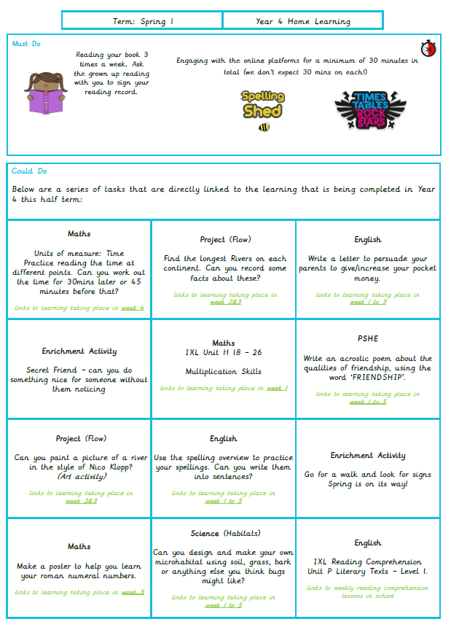

**Must Do**

These are activities that children are expected to complete every week and are classed as **non-negotiables**. This is because completion of these tasks is pivotal to your child’s successful learning progression. These tasks are:

* Reading their school reading book at least three times per week;
* Using age appropriate online platforms for a minimum of 30 minutes per week (total).

**Could Do**

These are a series of activities that link directly to the learning that will be taking place in the classrooms across the course of the half term. The week in which the learning is due to take place is **shown in green** within the document so parents and children can decide when to complete certain homework tasks.

There is no requirement for children to hand in homework to their class teacher for marking. However, the teaching team are always delighted to discuss, share and celebrate any learning completed outside of school and therefore children are most welcome to bring any completed tasks into school.

For more information, our Home Learning Policy can be viewed [here](https://primarysite-prod-sorted.s3.amazonaws.com/hatfield-community-free-school/UploadedDocument/36eb7adf-93fd-4c7b-95b5-a0b7d06d7e04/home-learning-policy-2023.pdf).